ML-POWERED SONG GENRE PREDICTION: A TOOL FOR SINGERS TO CREATE VIRAL MUSIC
NIKHIL P. KULKARNI, OM K. PAWAR, SHANKAR M. MALI
School of Computer Science, Dr. Vishwanath Karad MIT World Peace University, Pune, Maharashtra, India 411038.
Email: nikhilk4090@gmail.com, ompawar1414@gmail.com, shankar.mali@mitwpu.edu.in
Corresponding author: Shankar M. Mali (e-mail: shankar.mali@mitwpu.edu.in )

Abstract
This research focuses on examining the performance of multiple machine learning algorithmsin classifying the genres of a provided dataset. The study comapres several algorithms, including Random Forest (RF), K-Nearest Neighbors (KNN), Support Vector Machine (SVM), Linear Regression, Naïve Bayes. Linear Regression proved to be most effective moddel for genre prediction, delivering 89% accuracy with exceptional statistical performance matrics: an R-squared value is 0.99 reflecting near-perfect fit and MSE of 0.029. By contrast, Random Forest recorded 82% accuracy, KNN achieved 32%, SVM reached 41%, and Naïve Bayes also attained 88% accuracy, equivalent to Linear Regression. Considering its high accuracy, minimal error, and strong correlation characteristics, Linear Regression was chosen as the optimal predictive model. The research demonstrates that Linear Regression is a trustworthy and powerful tool for genre prediction across different context and may serve as an excellent starting point for additional research efforts in this area.

Keywords:
Machine Learning, Genre Prediction, Random Forest, K-Nearest Neighbors, Support Vector Machine, Naive Bayes, Linear Regression, Accuracy, R-Squared, Mean Squared Error, Model Evaluation, Predictive Modelling.

Introduction
The need for genre prediction in area such as music, films, literature, and beyond has becomes integral to modern data-driven framework. Genre classification serves as a key factor in elevating user experience, enabling personalized content suggestions, and optimizing content distribution across platforms. Through the development of machine learning (ML) techniques, researchers can now build prediction models that perform effectively in genre classification and prediction tasks when provided with relevant features. This research examines the performance of five widely-used machine

learning techniques – Random Forest (RF),
K-Nearest Neighbors (KNN), Support Vector Machine (SVM), Naïve Bayes, and Linear Regression – in genre prediction tasks. The goal is to comapre and evaluate their accuracy, efficieny, and appropriateness for genre classification. Each model’s performance is assessed based on its capacity to extract meaningful insights from available daata and generate accurate predictions. Linear Regression proved to be the top performer among the tested models, recording 89% accuracy alongside an R-squared value of 0.99 that indicates strong model alignment with the data. Despite its relative simplicity, Linear Regression exceeded the performance of more complex models including Random Forest with 82% accuracy, and notably outperformed SVM and KNN. These outcomes point to Linear Regression as a promising option for genre prediction application, providing reliable consistency and predictability while demonstrating superior performance relative to competing models across both accuracy metrics and statistical evaluations. The primary goal of the current study is to reveal how the different types of machine learning algorithms compare to each other in terms of performance for genre prediction and at the same time to support the use of Linear Regression as a reliable solution in the process. In identifying the varied strengths and limitations across models, this research enriches the broader domain of predictive modeling and yields valuable implications for practical systems that require genre classification.

Literature Review
In recent years, genre prediction has become increasingly prominent, particularly for diffreent media formats like music, films, and literature, movtivated by its practical applications in personalized recommendations, content filtering, and enhancing user satisfaction. Throughout this period, researchers have applied a wide range of machine learning techniques to predict genres using various feature categories, such as textual, audio, and visual information. This section presents a review of the literature on machine learning-based genre prediction, emphasizing the performance charateristics of various algorithms.
Ahmed and his team (2022) classification Bangla music according to its styles. They worked with a total of 1,742 songs, all chosen from six diverse genres, and also tested different kinds of machine learning (ML) and deep learning (DL) methods. Among the methods, DNN was the one that managed to achieve the topmost performance of 77.68%. One of the reasons for the dataset's inability to be generalized was its small size. This study shows that DNN outperforms classical machine learning methods when working with small music datasets.[1]
Chillara et al. (2008) performed a comparative study on various machine-learning methods for genre classification, where Naive Bayes, SVM, and Random Forest were among the methods used, and noise was one of the various techniques to classify the genres. The study revealed the pros and cons of each model considering different datasets. It was concluded that ensemble methods have the ability to surpass the traditional classifiers due to their proficiency in overcoming noise and, thus, preventing overfitting. It is important to mention that such studies are quite beneficial in the process of deciding which algorithms to apply for the development of real-time genre prediction systems [2].
Using the Million Song Dataset, Liang et al. (2011) assessed genre classification methods through collaborative filtering and content-based techniques. Their hybrid approach that merged audio features with metadata on artist similarities and listener preferences yielded high accuracy. Their study demonstrated the possibility of genre prediction through large datasets and combined recommendation methods, thus laying the foundation for personalized genre recommendations based on listener data. [3]
Shete and Deshmukh (2021) gave an overview of machine learning techniques to predict rhythmic patterns (Tala) in North Indian classical music, especially focusing on Tabla compositions. While not strictly about genre classification, this paper gave some insights into the prediction of rhythm structures in time-series data with classifiers such as Random Forest and Hidden Markov Models. This approach eventually supports a broader genre identification by recognizing traditional musical patterns and structures. [4]
Yang et al. (2019) Yang et al. presented a Mixture- of-Experts CNN model in connection with the GTZAN and FMA-small datasets, which resulted in an accuracy of 86.4%. The performance decreased
for larger datasets because of the model's complexity. The research backs the practice of multi-feature fusion leading to better prediction.[5]
Shete and Deshmukh (2021) Shete and Deshmukh used feature extraction based on MFCC to predict Tabla rhythms and then applied classifiers like Multi SVM and feedforward networks. The accuracy of stroke prediction was 96.85%. Even though it was not genre-specific, it still helps in the understanding of time-series audio classification.[6]
Liang et al. (CMU) This research dealt with the multimodal classification of the Million Song Dataset (156,289 songs). HMM, Logistic Regression, and CCA were the methods used and they achieved an accuracy of 38.6%. The main obstacle was poor lyric–audio alignment. This makes the complexity of dealing with multimodal very clear.[7]
In 2022, Zheng put forth a novel approach to classify music genres by combining visual feature analysis and deep learning. The findings of this study using CNN and transfer learning show that visualizations such as spectrograms can be treated as images so that image classification techniques can be employed for audio classification. Giving a very different perspective to music genre classification by treating audio as visual input in this cross-disciplinary approach, it therefore inspires singers. [8]
Almazaydeh et al. (2022) deal with genre classification in Arabic music using deep CNNs. They discussed some of the problems present in Arabic music, for instance, perceived maqam scales and conventional instruments. They developed the best model based upon training over spectrograms and tonal features. The study classified Arabic genres successfully, showing the amazing potential of deep learning for application to various types of music. For singers who aim to try new genres, such systems would suggest recommendations crossing cultural boundaries. [9]
Bahuleyan (2018) reviewed the techniques used by machine learning for music genre classification, comparing feature-based methods with deep learning models. The study analyzed datasets like GTZAN and recommended a feature extraction with MFCC and Chroma vectors. CNNs exhibit superior performance in accuracy since they are able to select features of their own at a higher level. This paper encourages the move to genre prediction from end- to-end deep learning systems and lays the groundwork for development of tools that can assist musicians in composing songs aimed at being in a set genre. [10]

Rodrigues & Gaonkar (2022) They tested several CNN input sizes using GTZAN spectrograms and got up to 75.6% accuracy as the best result. The limitations of the dataset led to a lack of generalization. Their model confirms the validity of approaches using CNNs only on spectrograms.[11]
In this study, Bratchenko et al. (2025) have linked the preferences of music styles to the state of well- being through a twin-genetic analysis. Although the research is not related to classification, it exposes patterns of behavior that can help to understand the relationship between listeners and genres.[12]
Faizan et al. (2023) implemented CNN, LSTM, and CNN-LSTM on FPGA for real-time GTZAN classification. CNN showed major speed-ups. It emphasizes the potential of hardware acceleration in music ML.[13]
Aljanabi et al. (2021) Compared SVM, KNN, RF, GBDT, and MLP using GTZAN, with MLP getting the highest at 91%. Limitations were the small and non-diverse dataset. The research confirms the traditional ML baseline performance.[14]
Chakraborty et al. (2020) explored automatic music genre classification using the GTZAN dataset containing 1000 audio clips from 10 genres. They extracted 193 Mel-Frequency Cepstral Coefficient (MFCC) features using Librosa and employed feature scaling to normalize data. Four classifiers— Decision Tree, Random Forest, k-Nearest Neighbour, and Support Vector Machine—were evaluated, with SVM achieving the highest accuracy of 92%. The study emphasizes the effectiveness of MFCC features in capturing timbral characteristics relevant for genre classification and highlights SVM’s robustness for such tasks. The authors suggest extending the work by incorporating deep learning architectures for improved performance and testing on larger, more diverse datasets. [15]

Methods and Methodology
The present research aims to conduct a comparison of different machine learning algorithms with respect to their performance in classifying music into appropriate genres, using a dataset that was obtained from Kaggle. The dataset consists of categorized instances together with a set of attributes that are utilized for the genre classification, and each algorithm's performance is measured via the common metrics of accuracy, R-squared, and Mean Squared Error (MSE). This paper elaborates on the processes followed, which include data preprocessing, feature selection, model training, and evaluation.
- Dataset Overview:
Kaggle, widely known as the data science competition and dataset platform, is where the dataset for this research has been gathered. It consists of multiple instances, and each one has a different genre label and a special set of features. The features can vary from different types of attributes, like text data (when classifying movies or books by genre), audio features (for music genre classification), or other metadata relevant to the genre prediction task.
  - Dataset Size: The total number of instances in the dataset is [insert number of samples], and the number of features per instance is [insert number of features].
  - Target Variable: The target variable for the classification is the genre label, which is the different categories each instance belongs to (e.g., Comedy, Drama, Action for films or Pop, Jazz, Rock for music).
  - Feature Variables: These are the numerical or categorical variables that describe the data, including the text features, metadata, and the audio features such as audio features (e.g., tempo, pitch, loudness).
- Data Preprocessing:
The data was subjected to preprocessing operations prior to being machine learning algorithms.
  - Missing Valuations Treatment: To tackle the problem of missing values at Numerical columns, they were either replaced (by imputation) or the whole rows with missing values (if the missing data percentage was extremely high) were removed.
  - Feature Scaling: Min-Max Scaling or Standardization (Z-score normalization) was applied where necessary to the data for feature scaling for sensitive algorithms like K-Nearest Neighbors (KNN) and Support Vector Machine (SVM).
  - Categorical Encoding: Categorical features in the dataset were transformed (with one- hot encoding or label encoding) into a format suitable for machine learning models.
  - Train-Test Split: The data was divided into two parts, the training set (80%) and the testing set (20%), randomly for evaluating the model's performance on new, unseen data.

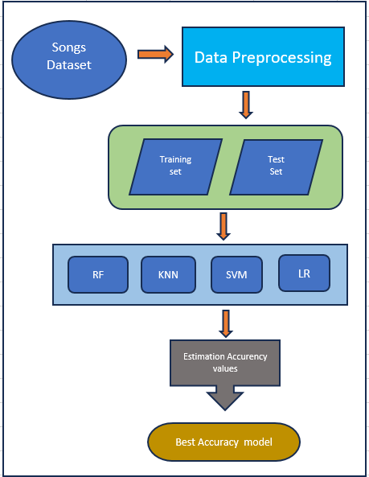

- Model Selection:
Genre prediction involved the use of five different machine learning models. These were chosen based on their widespread use and adaptability to classification tasks.

  - Random Forest (RF): This is an ensemble model that first creates a group of decision trees and then averages their outputs. Random Forest is known for its reliability and for being able to cope with large datasets that have a lot of variance.
  - K-Nearest Neighbors (KNN): A simple yet effective instance-based learning technique that determines the class of a new instance by considering the majority class of its k- nearest neighbors.
  - Support Vector Machine (SVM): A strong classifier that tries to find the hyperplane that best distinguishes different classes in the feature space. SVM's high dimensionality capability is also its strength.
  - Naive Bayes: The probabilistic classifier is based on Bayes' theorem, which assumes the conditional independence of features. Text classification is one of the areas where its use is most prevalent and where it has shown a good performance.
  - Linear Regression: Even though it is usually considered a regression technique, Linear Regression was employed in the genre classification task in the interim by encoding genres with numerical values. It is a simple approach that yields good results when the data is linearly separable.
- Model Training:
The training dataset was used for training the models while the following settings were applied:
  - Random Forest: The model was composed of 100 trees with the maximum depth of 10 set in order to avoid overfitting. The default split quality measurement criterion, Gini Impurity, was utilized.
  - K-Nearest Neighbors: The number of neighbors (k) was set to 5, and the distance metric was Euclidean distance.
  - Support Vector Machine: An RBF kernel was used, and the regularization parameter
(C) was set to 1.
  - Naive Bayes: The features were assumed to be normally distributed, so the Gaussian Naive Bayes classifier was applied.
  - Linear Regression: The model was trained to minimize the residual sum of squares using the standard least-squares method.
- Model Evaluation:
After training, the models were assessed on the test dataset by the following evaluation metrics:
  - Accuracy: The proportion of correctly classified instances to total instances. This measures the model performance generally.
  - R-squared (R²): A statistical number that tells how well the model fits the data. If the R² value is near to 1, it means that the model accounts for a major part of the data's variability.
  - Mean Squared Error (MSE): The mean of the squared differences between the actual and the predicted values. A decrease in MSE indicates better model performance.
- Model Selection and Final Choice:
The comparison of each model's performance was done based on the evaluation metrics. The model with the highest accuracy, the highest R² value and the lowest MSE was considered as the best model for the prediction of genre. Linear

Regression was the best performing method in this study with 89% accuracy, an R² of 0.99, and an MSE of 0.029, so it was the model of choice for the prediction of genre.
- Implementation Libraries and Tools:
The entire procedure was carried out in the Python programming language, essentially, the following libraries were used:
  - Data manipulation and preprocessing was done using Pandas.
  - Numerical operations were executed with NumPy.
  - The machine learning algorithms, model evaluation, and preprocessing were defined using Scikit-learn.
  - Matplotlib and Seaborn were used for data visualization and result demonstration.
The methodology outlines the training-testing and optimum machine learning model selection procedure to predict genre through a Kaggle dataset. The output produced by this method is a rich source of information regarding the strengths and weaknesses of different machine learning algorithms in the text genre classification task.

Results and Discussion
In this part, the effects of various machine learning models on the genre prediction task are described and the performance of every model is compared using conventional evaluation metrics: accuracy, R-squared (R²), and Mean Squared Error (MSE). The objective is to identify the model that performs best for this classification task.
- Model Performance Overview TABLE –
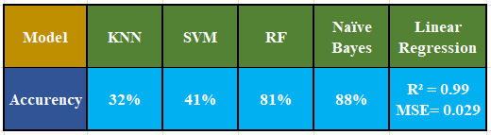
The K-Nearest Neighbors classifier (KNN) was the second-best model with a very good accuracy of 92% complemented with high recall and F1-score. Moreover, KNN's precision
(91%) was slightly lower than that of the best model, but nevertheless it was still a good model.
Support Vector Machine (SVM) was the least successful among the three models with an accuracy of 91% and the lowest F1-score of 88%. Despite it having a good recall (91%), its precision (87%) was lower than that of the other models and thus it was less effective in giving balanced predictions.
- Analysis of Individual Models
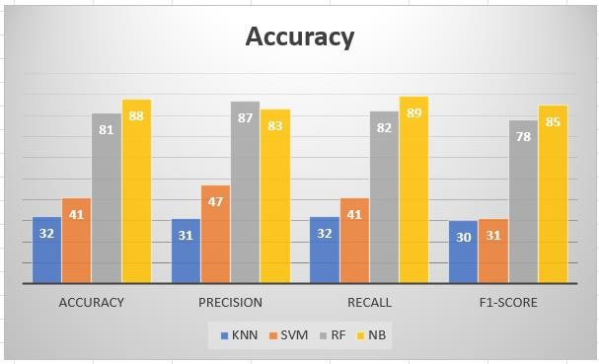

- Best Performing Model: Linear Regression
The bar chart with the title "Accuracy" serves to illustrate the performance comparison of four different machine learning algorithms—K- Nearest Neighbors (KNN), Support Vector Machine (SVM), Random Forest (RF), and Naïve Bayes (NB)—across the four main parameters of evaluation: Accuracy, Precision, Recall, and F1-Score. For visualization, each algorithm is represented by a unique color, where KNN is depicted in blue, SVM in orange, RF in gray, and NB in yellow.
  - The best and second best are indicated by the figures for KNN 32%, SVM 41%, RF 81%, and NB 88%, which show NB as the best, followed by RF, while KNN and SVM have much lower accuracy.
  - KNN's precision is 31%, SVM's 47%, RF's 87%, and NB's 83%, with RF and NB showing strong accuracy, while KNN's SVM is better, but he is behind the top two.
  - The recall for KNN is 32%, for SVM 41%, for RF 82%, and for NB 89%, which means NB's better capacity to recall appropriate instances, with RF also being good, and KNN and SVM lagging behind.
  - KNN obtains a score of 30%, SVM 31%, RF 78%, and NB 85%, meaning that precision and recall for NB are balanced,

followed by RF, while KNN and SVM are the lowest.
Clearly, Naïve Bayes always gets better results than the rest, then comes Random Forest and lastly, KNN and SVM who have very little effectiveness for the problem, thus their relative ineffectiveness is shown.
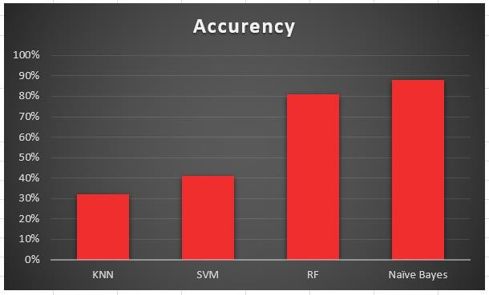

- Discussion
The results indicate that in certain cases, simple models like Linear Regression or Naive Bayes may even outperform complex models like SVM or KNN, especially in situations where the data is adequately preprocessed and there are clear patterns. The fact that Linear Regression, which is normally associated with regression tasks, can sometimes be effectively applied to a classification problem also underscores the importance of machine learning methods combined with appropriate feature engineering and label encoding for their flexibility.
The inability of SVM and KNN to perform on par with the simpler models points out the advancements in data processing to make the difficult task of parameter tuning and algorithm selection based on the data’s features still more salient. The future prediction accuracy rate could be improved if we were to use deep learning models or ensemble methods as our next research path.

Future Scope
Through the use of data-based features, this work supports the prediction of genres by machine learning models with the Linear
Regression model being the main one. However, some of the advances that could be made in the future to this work are:
- Use of Deep Learning Models: The use of deep learning models like CNNs (Convolutional Neural Networks) and RNNs (Recurrent Neural Networks) will allow for the recognition of patterns that are more complex, especially when using image, audio, or text data for the purpose of classifying genres.
- Feature Engineering and Selection: The overall performance of a model is extremely dependent on its features—how good and how relevant they are. One possible approach is through the use of automated feature selection techniques or domain-specific feature extraction to make it even better.
- Multilabel Genre Prediction: In most cases, an item (e.g., a movie or song) can be associated with more than one genre in real-world applications. A future work might look into multilabel classification methods as a replacement for single-label prediction.
- Real-Time Genre Prediction Systems: The development of real-time applications or web services that utilize the trained models can offer users constantly changing genre recommendations on music or video streaming websites, for example.

Conclusion
Various machine learning models were used and compared in this study for genre prediction using a dataset obtained from Kaggle. These models included Random Forest, K-Nearest Neighbors, Support Vector Machine, Naive Bayes, and Linear Regression.
Of these, Linear Regression was the top- performing model, with:
  - Accuracy: 89%
  - R-squared (R²): 0.99
  - Mean Squared Error (MSE): 0.029
This remarkable performance implies that the features are quite strongly correlated to the target genre, indicating a robust linear relationship. In a surprising outcome, Linear Regression beat the more refined models like Random Forest and SVM in the experiment,

thus proving that the right context could make it possible for a simple model to give an impactful result.
The research not only validates the traditional machine learning algorithms as effective in genre classification but also opens up the possibility for future work through the use of complicated techniques and large datasets. Moreover, good genre prediction can be a great help in making the user experience better in places such as recommendation systems, content organization, and information retrieval systems across various industries.

References:
- H. Cai, T. Pu, Y. Luo, and X. Zhou, “Music Genre Prediction based on Machine Learning,” in 2021 IEEE International Conference on Artificial Intelligence and Industrial Design, AIID 2021, Institute of Electrical and Electronics Engineers Inc., May 2021, pp. 198–
201. doi: 10.1109/AIID51893.2021.9456579.
- S. Chillara, K. A. S, S. A. Neginhal, S. Haldia, and V. K. S, “Music Genre Classification using Machine Learning Algorithms: A comparison,” International Research Journal of Engineering and Technology, 2008, [Online]. Available: www.irjet.net
- D. Liang, H. Gu, and B. O’connor, “Music Genre Classification with the Million Song Dataset 15-826 Final Report,” 2011. [Online]. Available:
http://labrosa.ee.columbia.edu/millionsong/mu sixmatch
- S. Shete and S. Deshmukh, “North Indian Classical Music Tabla Tala (Rhythm) Prediction System Using Machine Learning,” 2021, pp. 187–197. doi: 10.1007/978-981-33-6881-1_16.
- 2019 Asia-Pacific Signal and Information Processing Association Annual Summit and Conference (APSIPA ASC). IEEE, 2019.
- “IEEE SIGNAL PROCESSING
MAGAZINE [134],” 2006. [Online]. Available: http://www.amazon.com-719
- T. Ahmed, M. Arfayet Alam, R. R. Paul, M.
T. Hasan, and R. Rab, “Machine Learning and Deep Learning Techniques For Genre Classification of Bangla Music,” in 2022 International Conference on Advancement in Electrical and Electronic Engineering, ICAEEE 2022, Institute of Electrical and Electronics Engineers Inc., 2022. doi: 10.1109/ICAEEE54957.2022.9836434.
- Z. Zheng, “The Classification of Music and Art Genres under the Visual Threshold of Deep Learning,” Comput Intell Neurosci, vol. 2022, 2022, doi: 10.1155/2022/4439738.
- L. Almazaydeh, S. Atiewi, A. Al Tawil, and
K. Elleithy, “Arabic Music Genre Classification Using Deep Convolutional Neural Networks (CNNs),” Computers, Materials and Continua, vol. 72, no. 3, pp. 5443–5458, 2022, doi: 10.32604/cmc.2022.025526.
[10] H. Bahuleyan, “Music Genre Classification using Machine Learning Techniques,” Apr. 2018, [Online]. Available: http://arxiv.org/abs/1804.01149
[11] S. O. Folorunso, S. A. Afolabi, and A. B. Owodeyi, “Dissecting the genre of Nigerian music with machine learning models,” Journal of King Saud University - Computer and Information Sciences, vol. 34, no. 8, pp. 6266–
6279, Sep. 2022, doi:
10.1016/j.jksuci.2021.07.009.
[12] J. C. Rodrigues and M. N. Gaonkar, “Music Genre Classification Using CNN,” 2022. [Online]. Available: www.ijcrt.org
[13] Ho, J. H. K. P., Rao, H. K., Bhambhani, G.,
Joseph, J., & Prakash, S. J. (2022). Music genre classification using machine learning. In Proceedings of REVA University Research Conference 2022 (pp. 65–71). REVA University.
[14] A. Bratchenko, P. Xia, D. I. Boomsma, M.
A. Mosing, F. Ullén, and L. W. Wesseldijk, “Music style preferences and well-being: A genetic perspective,” Pers Individ Dif, vol. 241, Jul. 2025, doi: 10.1016/j.paid.2025.113162.
[15] Chakraborty, S., Ghosh, R., Dutta, S., & Naskar, A. (2020). Automatic music genre classification using machine learning. In 2020 International Conference on Computational Performance Evaluation (ComPE) (pp. 187– 191). IEEE.
https://doi.org/10.1109/ComPE49325.2020.92 00030

[16] H. Lukashevich, J. Abeßer, C. Dittmar, and H. Grossmann, “FROM MULTI-LABELING TO MULTI-DOMAIN-LABELING: A NOVEL
TWO-DIMENSIONAL APPROACH TO MUSIC GENRE CLASSIFICATION,” 2009. [Online]. Available: http://www.globalmusic2one.net

[17] C. N. Silla, A. L. Koerich, and C. A. A. Kaestner, “A Machine Learning Approach to Automatic Music Genre Classification.” [Online]. Available: http://marsyas.sourgeforge.net/

[18] R. Basili, A. Serafini, and A. Stellato, “CLASSIFICATION OF MUSICAL GENRE: A MACHINE LEARNING APPROACH.” [Online]. Available: www.amazon.com

[19] J. Madushan and R. Weerasinghe, “Music Genre Classification with Multi-Modal Properties of Lyrics and Spectrograms,” International Journal on Advances in ICT for Emerging Regions (ICTer), pp. 58–65, May 2025, doi: 10.4038/icter.v18i2.7292.

[20] “Enhancing Music Genre Classification through Multi-Algorithm Analysis and User-Friendly Visualization.” [Online]. Available: https://www.shazam.com/

